**TIPS / GUIDELINES FOR PRE-RECORDING:**

Speakers can contact me directly if they have any questions:

Alex Frois

07445942739

**INTRODUCTION / QUICK START**

So we want to record your video / web cam and your screen *separately* into two videos.

Some people have experienced issues with compression and files sizes so to make this easier my new recommendations for the easiest experience are as follows:

1. Use your mobile phone, the front facing or rear facing camera to capture a video of yourself giving the talk. This will provide optimal files sizes and compression for a 30min talk.
2. Keep the device within adequate distance in a quiet room for audio capture; the on-board microphone should be sufficient.
3. Screen Record your presentation on Mac using Quicktime and ensure the microphone is also selected for capturing audio. We will then be able to synch up the two video streams easily.

**IMPORTANT QUICK TIPS**

1. Record widescreen ratio – ***do not*** *record square or vertical video on your phone.*
2. **Record in just 1 Part!** Try not to break recordings into multiple files. If you need to pause or go back, leave a 10 second gap and just let us know – we’ll find it in the video.
3. Please refrain from using Airpods or other wireless Earbuds; the audio quality is not good. Your Macbook microphone will be superior in most cases unless you have a reasonable quality USB microphone.
4. Keep your laptop / smart phone raised on some books / a counter so the camera is eye-level. This avoids the ‘up the nose look’
5. Stay in reasonable proximity to your laptop microphone for best quality
6. Try to ensure your room is quiet
7. ***If you are recording Code / demos – please make sure the text size is at least 50% larger and clearly visible.***

**RECORDING YOUR WEBCAM & SCREEN USING ONLY QUICKTIME**

QuickTime is the best for quality.

What we’ll do is create two recordings.

One of your Webcam and the other of your screen / presentation.

Select ‘New Movie Recording’ to record your **webcam**.

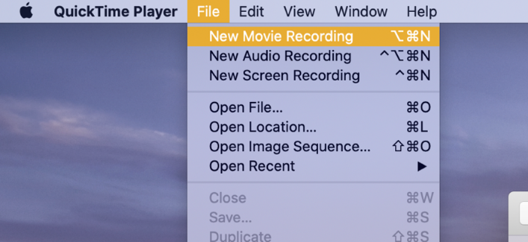

Select the drop-down next to the record button and select ‘Maximum’ quality.

Check your Microphone is active.

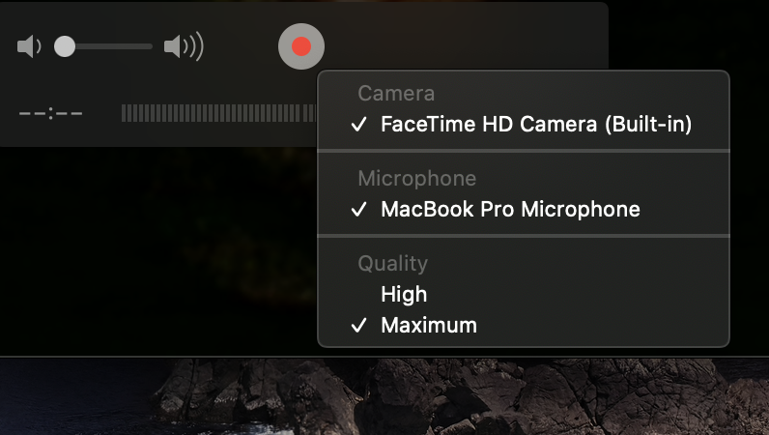

*It’s reported Maximum will create approximately 13gb for a 30min talk.*

*Selecting High instead of maximum will yield smaller files if you’re short on HDD space*

***Good vs Bad Examples***

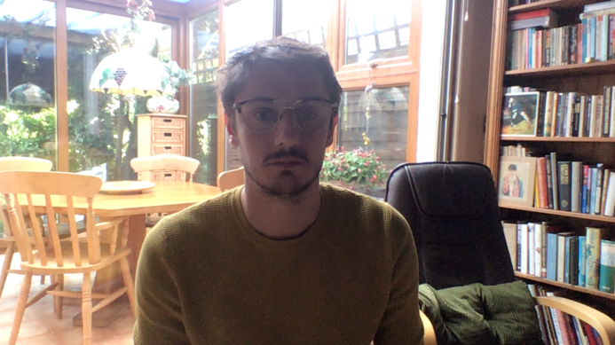*This applies to mobile phone and web cam recording*

Left: Bad example – low angle, looks up nose  
Right: Bad example – bright window in background causes over exposure and can’t see face



Left: Better example – camera is eye level and light is on face

Right: Best example – camera is eye level and window light is exposing the face properly

*Continued…*

**SCREEN RECORDING**

Select ‘New Screen Recording’ to initiate **screen recording.**

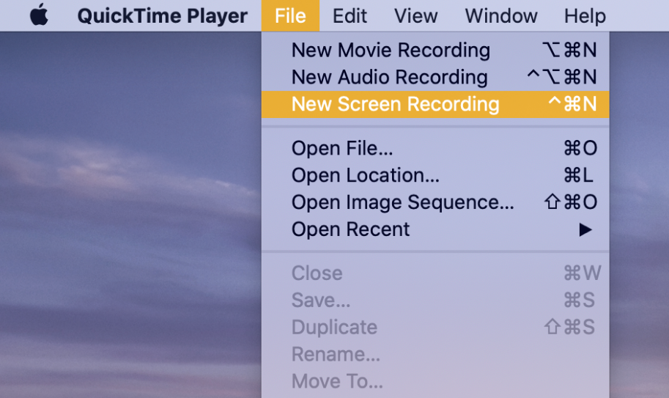

Select the ‘Show Mouse Clicks’ via the options if relevant and the ‘Entire Screen’ Symbol.

*Please ensure ‘MacBook Microphone’ is selected so your audio is recorded with the screen.*

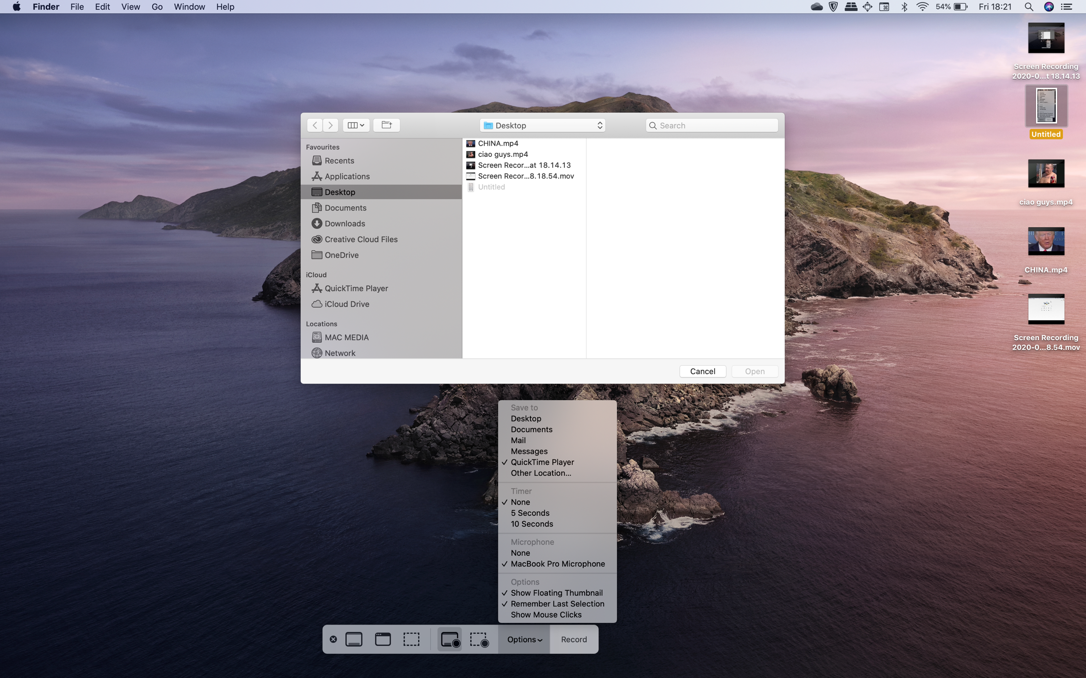

You can also select to automatically save to Desktop.



After the recording please ensure it is properly saved.

**ALTERNATIVES**

If on Windows, ALT-G brings up the Gamer Bar which provides some screen recording options. This may not be useable if recording slides and in browser demos.

**Q&A STREAMS:**

* Alex will confirm on taking a voice / video feed for the Q&A after the talks
* Questions will be asked in the comments
* If an organiser can join the Q&A feed to prompt questions that will help with curation
* Alternatively, the speaker can read out and respond to questions directly.

**ORGANISER INTRO’S**

Live intro’s will be tested briefly over video call on the afternoon of the event

**LIVE Q&A OPTIMISATIONS**

A test will be carried out on the afternoon event just to get everyone prepared

* We’ll do it over **Google Hangouts.**
* **I’ll send a meeting link people can tune in to.**
* You don’t have to be on video – can be audio only if preferred.

The live-stream is delayed about 10 seconds.

It is recommended you have the live-stream playing on e.g a tablet / phone

Then have yourself on the video call  via your laptop (or vice versa laptop – tablet/phone)

Alex will be on the call too.

He will queue people in for when we’re cutting to Q&A

Again, we’ll be operating approximately 10 seconds ahead of the live stream you’ll be watching

**Organisers**

If you can curate the Q&A; forward questions to the speakers from the comments. Get the conversation started.

Additionally – if there aren’t many questions in the comments – if speakers can conversationally drum up some points that would be useful and start the conversation.

**TECHNICAL OPTIMISATION**

Ensure your internet connection is uncluttered or occupied.

I.e have the stream playing over your 4G connection.

Be on the call via your home WIFI.

Use your best microphone to be on the call; i.e the laptop you recorded your talk with.

Avoid Airpods / wireless buds

Stay in relatively close proximity to your microphone